MINECOFIN Quarterly Macro-Fiscal Outlook (QMFO)—2023-27

Background
This pilot QMFO presents for the first time MINECOFIN-MPDG staff’s short- to medium-term forecast for macro aggregates under current fiscal, monetary and exchange rate. It analyzes recent macroeconomic developments over the business cycle characterized by fluctuations in real GDP and inflation around their trends, interprets transmission mechanisms of shocks and policy responses, and forecasts key macro aggregates under baseline and alternative policy scenarios. It emphasizes fiscal variables and MINECOFIN’s concern about stabilizing output, maintaining levels of living, and keeping the longer-term growth potential.
The Outlook—produced quarterly along with results of macro framework and NBR forecasting tools—should help generate the validated macro-fiscal projections that underpin the (medium-term) Budgets and IMF-supported programs and facilitate coordination of policies between MINECOFIN and NBR. In the process of reconciling the results from various tools, iterative policy scenarios are run, and recommendations formulated outside the Outlook. MINECOFIN’s independent assessment of the macro-outlook and the effects and interactions of fiscal with other policies—which may differ from those in other tools—should further enhance the macroeconomic analysis and policy debate.
The underlying quarterly model QMFM is a ‘New-Keynesian’ semi-structural ‘gap’ model. It is New-Keynesian as it has nominal and real rigidities, it is structural as most equations have an economic behavioral interpretation, and it is a gap model as it traces key macro variables—output, inflation, exchange rate, and interest rate—over the business cycle in deviation from their trend or target levels. After shocks and policy responses have worked out, all variables return to their trend path which converge to their steady-states levels, determined outside the model (e.g., potential GDP growth, CPI target, real interest rate, real exchange rate depreciation rate, etc.).
The QMFM captures fiscal, monetary, and exchange rate policies—with policy rules or guides and scope for discretion for each—and their effects and interactions. It is distinct from other FPAS models as used by central banks in several ways: (i) the elaborate fiscal and financing/debt block with deficit and its constituent parts (revenue, spending on goods and services, other spending) and their discretionary, cyclical, and structural components; (ii) the breakdown of demand into five components each with its own equation; and (iii) the derivation of variables in levels allowing comparison with other macro projections.
Section I reviews recent macro developments (16 quarters past), interprets updated trends and gaps for key macro variables, e.g., output, RIR and RER (using data for 2006-23). Section II sums up the policy stance and initial conditions for the forecast. Section III provides forecasts (16 quarters ahead) given exogenous external variables, expected fiscal policy stance, near-term/judgmental forecasts and modeled monetary and exchange rate policy rules. Section IV provides supplemental information: comparison with projections from macroeconomic framework and alternative scenarios with slower declines in world food and oil prices, and possible policy responses.

Summary Outlook
- Current policy stance. Modestly tight monetary policy, fiscal consolidation in 2022/23 reinforced with the FY2023/24 Budget, and exchange rate policy entailing initially some overvaluation have helped contain domestic demand and bring inflation down in 2023.

- Inflation (CPI headline, y-on-y) is expected to continue its gradual decline, but with a modest flare-up in late 2023/early 2024 resulting from food price shocks in Q4, the pump price increase in October, and passthrough of exchange rate depreciation in preceding quarters. From 2024Q4, inflation should be close to 5%, reflecting modest drops in world food and oil prices, improved domestic food supply, and fading of earlier shocks.

- Output. Real GDP growth (y-on-y growth) is expected to remain sluggish and below its trend level in 2023Q3─2024Q1. After that, it is forecast to rise to above trend for 10 quarters (almost 10% on average) helped by temporarily lower nominal and real interest rates and higher RER. The output gap (GDP below potential, estimated at -7% at end-2023) should dissipate by early 2026 and output growth return to its trend of 7.5% p.y.

- Fiscal impact. The planned reduction in deficits (excluding grants) for FY2023/24-2024/25 (to an average of 10.3% of GDP from 13.5% in FY2020/21-2022/23) entails a drop in government demand for G&S of similar magnitude and exerts a negative effect on private demand. This fiscal stance is forecast to impact total demand and output negatively by some 1.2% of GDP.

- Interest rate and RIR. The interbank (IB) rate is forecast to be gradually lowered from 2024Q1 onward, in line with the declining inflation and remaining output gap, then move back up to the neutral interest rate estimated at some 7.5%. The RIR (interbank rate minus one-quarter ahead CPI-core) is forecast to continue its recent rise as inflation drops, then fall as the IB rate responds to negative output gaps for10 quarters, before moving back up to its trend level (of 2.5%) toward the end of the projection period. The RIR impact on private demand is initially negative, then positive for 10 quarters, before going back to neutral after 2027.

- Exchange rate and RER. The nominal exchange rate is forecast to gradually return to a less fast depreciation path of 3-4% per year (down from 17% in 2023), since the recent overvaluation has been reversed, and the exchange rate policy rule mainly adjusts for inflation differentials. In 2024-25, this RER path is much below the PCI program path. The RER is forecast to show a decelerating pace of depreciation (from its high in 2023) to return gradually to its trend level (and zero trend depreciation rate) from 2025. The sharp upward correction in the RER should favorably affect demand for net exports in 2023-24, but the effect should fade out thereafter.

MINECOFIN Quarterly Macro-Fiscal Outlook (QMFO)—2023-27 1
I. Recent macroeconomic developments, 2019-23 4
A. External environment 4
B. Output and final demands 4
C. Fiscal policies and government demand 6
D. Inflation and its components 10
E. Nominal/real interest and exchange rates 12
II. Current macro policy stance and initial condition 16
A. Current cyclical position 16
B. Fiscal policy stance 16
C. Monetary and exchange rate policy 17
III. Macroeconomic outlook, end-2023─end-2027 18
A. Forecast assumptions 18
1. External environment assumptions (WEO and other sources) 18
2. Domestic environment assumptions 19
3. Fiscal policy assumptions 19
B. Summary of macroeconomic forecast 20
C. Macroeconomic forecast narrative 21
1. Output (GDP) and cyclical position 21
2. Private final demands and cyclical position 23
3. Fiscal policies and government demand 26
4. Inflation (CPI) 30
5. Policy interest rate and real interest rate 34
6. Exchange rate (ER) and real exchange rate (RER) 36
D. Summary of policy stance and forecast 39
IV. Supplementary information 41
A. Comparison with Macroeconomic Framework projections 41
B. Alternative scenarios and policy responses 42
1. Scenario of higher foreign food and oil prices in 2023-24 to be updated 42
2. Possible domestic policy response 43
Annex 1. Rwanda Quarterly Macro-Fiscal Model (QMFM) main features 44
Annex 2. Model calibration/filtering using model properties and historical data (2006-23Q2) 49
Annex 3. Recent developments of other final demands and decomposition (2015-23Q2) 50
Annex 4. Fiscal block: deficit, fiscal policies, and fiscal impulse in the model 52

Recent macroeconomic developments, 2019-23
This section assesses recent macro developments since just before Covid using a macro model. The model identifies the drivers of key macro aggregates, is calibrated to fit full data for 2006Q1-2023Q2 and to obtain plausible trends and other unobserved variables using exogenous information and judgment for various parameters, and provides the initial conditions for the forecast.

External environment
Rwanda’s external environment in 2021-23 was overall less favorable than in 2019-20, with favorable factors more than offset by unfavorable ones. With increases in import prices far exceeding those in export prices, the commodity terms of trade fell significantly over the period (Table 1).
Table 1. Rwanda’s external environment in recent years, y-on-y % growth (unless indicated otherwise)
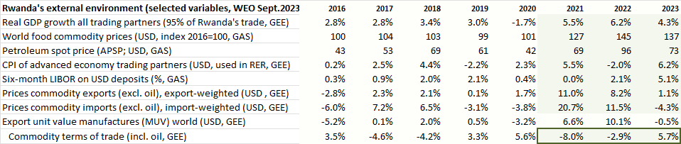
On the favorable side, trading partner demand grew at over 5% p.y., from less than 1% on average in 2019-20, narrowing the negative foreign output gap relevant for exports, boosting tourism and a few commodity exports. International interest rates were below 2% until 2022 when they started to increase as monetary policies tightened around the world to combat inflation induced by post-Covid pent-up demand, supply chain disruptions, and the war in Ukraine. However, interest rates remained negative in real terms.
Prices of Rwanda’s exports rose much in 2021-23 (coffee, tea, metals), but sharp increases in import prices more than offset the favorable export prices. Petroleum import prices doubled during 2021-22 and stayed high in 2023, and world food prices rose steeply from early 2021 and were some 40% above their 2019-20 level during 2021-23. Manufacturing prices also rose due to supply bottlenecks. Thus, Rwanda’s import prices as projected in WEO-GEE rose sharply in 2021-22 before stabilizing in 2023. As a result, the commodity terms of trade fell by a cumulative 6% during 2021-23.

Output and final demands
Output. Real GDP growth averaged 7½ percent during 2000-19. Growth was above average—and output estimated to be a bit above potential—in 2019. Under Covid, Rwanda’s economy contracted in 2020Q2 (total lockdown), and y-on-y growth was negative in 2020Q2-4 (-12%, -4% and -1%) as supply constraints and external and domestic demand drops lowered production. In 2020, GDP dropped by -3.4% from 2019 and was almost 12% below its potential level had normal growth of 7.5% continued. Expansionary fiscal policies from 2020Q2 mitigated losses in income and consumption of households and enterprises, contained GDP losses in 2020 and helped the subsequent recovery. Despite the strong bounceback in 2021, output is estimated to have remained below potential level since then, as global instability related to the war in Ukraine slowed down the recovery from 2022Q1 onward (Figures 1.1 and 1.3). Although it is difficult to assess potential GDP when large shocks like Covid may leave permanent scars to production capacity, GDP is estimated to be almost 6% below potential in mid-2023.
As consumption is about three-quarters of GDP, the drop in consumption accounts for a large part of the down pull of GDP levels since Covid (Figures 1.2 and 1.3). The drop in imports during Covid due to both foreign supply constraints and lack of demand, constituted a favorable shift toward domestic demand and offset somewhat the down pull effect of lower domestic and export demand. Consumption and investment recovered quickly, but exports remained sluggish until end-2022.
Figure 1. GDP-output: growth, gap and components, 2015-23
Fig. 1.1 Output level (blue) and trend, loglevels (l_y)  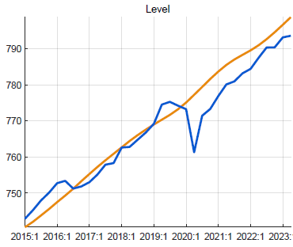 | Fig. 1.2 Output growth by demand component
Covid years (2020-21)  - consumption and investment accounted for most of the GDP drop and output gap  - the fall in imports and expansionary government demand helped mitigate the downpull on GDP  Immediate post-Covid (2021-22)  - consumption and investment contributed most to the recovery  - supported by continued government demand, while exports remained sluggish  Ukraine-war (2022-23)  - post-Covid recovery slowed down due to jumps in international oil and food prices, causing high inflation and drop in real consumption and other demand  - fiscal consolidation started (though in part thwarted by floods) and lowered the expansionary effect of govt demand |  | Fig. 1.3 Output gap (vis-à-vis trend) and components
Consumption. Private consumption shows strong fluctuations in part due to its residual nature in national accounts estimates. During the 2020-21 Covid years, the drop in private consumption due to lockdown and ensuing income losses (multiplier effect) featured the largest shocks (in % of GDP) of all final demands. The adverse impact was exacerbated by the relatively high RIR (until mid-2021 as inflation was very low, with nominal interest rates quasi-constant), but partly offset by fiscal expansion (see below) (Figure 2). The upturn in consumption was uneven as Covid impacts resurfaced and the Ukraine war in early 2022 interrupted the post-Covid economic recovery. By end-2022, consumption had returned to normal, but dipped strongly in early 2023 as inflation eroded purchasing power.
Figure 2. Consumption: growth, gap and components, 2015-23
Fig. 2.1 Consumption level (blue) and trend, loglevels (l_cons)  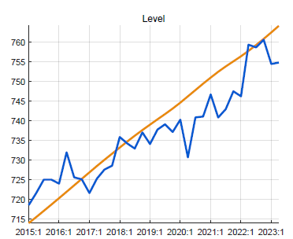 | Fig. 2.2 Consumption gap (vis-à-vis trend) and components

Fiscal policies and government demand
Fiscal policies affect output directly as government spends on G&S and—to a much smaller extent—indirectly as fiscal deficits—via taxation, transfers, net lending—affect disposable incomes and hence private demand. This study traces both effects separately, by describing each of the deficit constituent parts (revenue, spending on G&S, other spending) and their discretionary, cyclical, and structural components, all expressed as ratios of GDP since fiscal policies are mostly conceived that way. The deficit (excluding grants) fluctuates over time around its trend—determined by longer-term financing constraints—mainly due to discretionary spending in response to crisis or ad-hoc needs, and to a lesser extent due to variations in other spending and revenue in line with the business cycle. For each constituent part, the components are distilled from the data by identifying movements with the business cycle and trends. The components of the deficit are the sums of the components of the constituent parts, e.g., the cyclical deficit is cyclical spending on G&S plus cyclical other spending minus cyclical revenue.
The deficit has fluctuated around 11% of GDP in the last 8 years, but was higher in Covid years, mainly due to higher spending on G&S as a ratio of GDP (Figure 3.1). The structural deficit—deficit before grants corrected for cyclical and discretionary components which cancel out over the business cycle—has trended slightly downward over the last 8 years (from 14 to 12% of GDP), as access to financing and infrastructure investment declined. The discretionary deficit is mainly driven by government discretionary spending, notably on G&S and was large during Covid, and has declined thereafter. The relatively small cyclical deficit is driven by cyclical other expenditure (transfers and subsidies to households and enterprises) and revenue collection, which as a ratio of GDP increase and decrease, respectively, with a downturn (and vice versa with an upturn) (Figure 3.2).
Fig. 3.1 Fiscal deficit: revenue (-), spending G&S (+), and other spending (+), % of GDP | Fig. 3.2 Fiscal deficit: structural, cyclical, and discretionary, % of GDP
Tracing the deficit and its parts and components serves to distil the fiscal policy stance and its direct effect (government demand for G&S) and indirect effects (via private demand) on output.
Government demand—defined as spending on G&S for consumption and investment, 24% of GDP in 2006-23—has a direct effect on demand and output and—of all fiscal policies—has the largest effect on output as well on the fluctuations in the deficit. The trend in government demand is considered the same as structural government demand (in % of GDP times trend GDP), and thus government demand above (below) trend—i.e., discretionary plus cyclical spending—affects output in the business cycle. As those policies are largely expressed as ratios of GDP, a positive (negative) output gap itself means higher (lower) government demand.
In the years before Covid, government demand had been below trend, mainly due to a decline in foreign-financed investment projects. The Covid-response measures spanning fiscal years 2019/20-2021/22, raised government demand well above its trend level (on average by over 2% of GDP) and helped counter the Covid-induced output drop (Figures 1.3 and 3.3). Government demand in deviation from its trend or structural level reflects mainly discretionary spending (Figure 3.4).
After the expansionary Covid response, however, from late 2022, government demand went into reverse as the deficit was reduced to bring down debt that had risen rapidly in previous years. At the same time, surging inflation further reduced government demand in real terms. Though government demand was raised in response to floods in 2023Q2, this barely changed the deficit reduction.
Figure 3. Government demand: as ratio of GDP and gap vis-à-vis its trend, 2015-23
Fig. 3.3 Govt demand for G&S, % of GDP  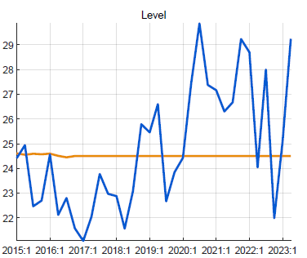  - government demand was below trend level during 2015-19 as investment was cut  - during Covid years, government spending shot up, esp. on health and education  - this government spending helped contain the downturn induced by Covid lockdowns  - after Covid, with 2022/23 budget, govt spending was reduced quickly, but went up in 2023/Q2 in response to floods | Fig. 3.4 Govt demand gap (vis-à-vis trend) and drivers, %

Fiscal impulse onto private demand. As noted above, this study separates the direct effect on output of government spending on G&S from the indirect effect of fiscal policy (as gauged by “fiscal impulse”) on private consumption and investment and hence output. The fiscal impulse—largely discretionary deficits—was on average about 2% of GDP during Covid years 2020-22 (Figure 3.5).
The fiscal impulse was largely reversed as fiscal consolidation took hold from late 2022, but consolidation was in part interrupted by the flood crisis in 2023Q2. The discretionary deficit is the main driver of the fiscal impulse to private demand, together with the change in the structural deficit which is very small. The discretionary deficit affects private demand because other expenditure (transfers, subsidies, net lending) and lower revenue collection increase disposable incomes, while discretionary govt demand for G&S boosts private sector spending optimism.
Fig. 3.5 Components fiscal impulse, onto private demand, % GDP | Fig. 3.6 Fiscal stance: effect on GDP via govt demand and private demand, % GDP

Fiscal stance total effect on output. The combination of government demand (affecting output directly) and “fiscal impulse” (via private demand, affecting output indirectly) makes for a strong short-term impact of fiscal policy. An average positive discretionary deficit of 2% of GDP—as was realized during Covid—raises real GDP by some 1.7% points: by 1% point directly and by 0.7% point indirectly via private consumption (0.5%) and investment (0.2%), after netting out import shares in each demand.

The other final demand components—private investment, exports, imports—are discussed in Annex 3.

Inflation and its components
Inflation in Rwanda is characterized by high volatility, mostly driven by factors unrelated to the business cycle. The main factors are weather-induced fluctuations in harvests and agricultural prices, openness and dependence on imports, especially for food and petroleum products with volatile international prices, and lack of competition in many markets. Food and energy price increases are often transmitted to increases in domestic core prices, so that food and energy prices contribute to volatility of headline inflation both directly and indirectly. The recent Covid and Ukraine crises underline the vulnerability to domestic and external price shocks as weak harvests and soaring domestic agricultural prices coincided with surging world food and energy prices (Figures 4.1-2).
Figure 4. CPI Headline and components, y-on-y %, 2006-23
Fig. 4.1 CPI core, food and energy: historic volatility | Fig. 4.2 CPI headline and trend, y-on-y %  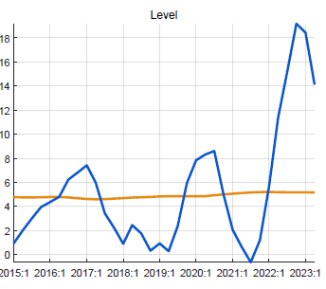
With a 16% weight, food price fluctuations contribute most to fluctuations in headline CPI, while energy with a 7% weight contributes much less (Figure 4.3). The relative price of food is found to be on an upward trend (Figure 4.4).
Fig. 4.3 CPI headline components  (weighted with shares in CPI basket) | Fig. 4.4 Relative price of food, vis-à-vis CPI headline 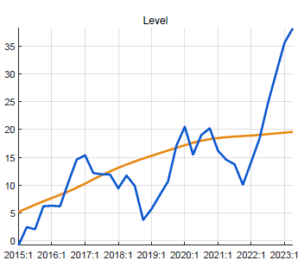
Core inflation is driven by a lag, expectations, direct import price effect, output gap and indirect import price effect (REER). However, it has large “unexplained” shocks, especially during Covid (negative shocks reflecting the lockdown) and the recent Ukraine-war induced inflation (positive shocks) (Figure 4.5-6). Thus, a large chunk of the recent core inflation is not due to the standard factors, including the output gap. This implies that the core Phillips curve in Rwanda has only a weak relationship with the output gap and this weakens the last step of the transmission of monetary policy, to real interest rates, to output gap, and to inflation.
Fig. 4.5 Drivers of CPI core inflation | Fig. 4.6 Direct effect foreign prices on CPI core  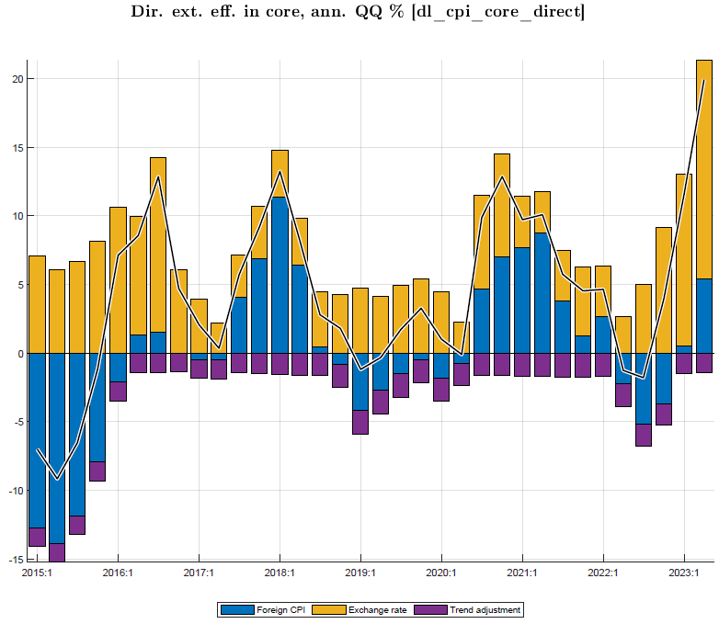
The drivers of food and energy are similar but with no impact of the output gap, with much larger shocks than for core CPI, smaller impacts of REER, and larger direct impacts of foreign prices. The CPI food is affected by the agricultural output gap (with negative sign) as good harvests mean lower agricultural food prices (Figures 4.7-8). The shocks for food and energy are downward in 2023Q1-2.
Fig. 4.7 Drivers of CPI food inflation  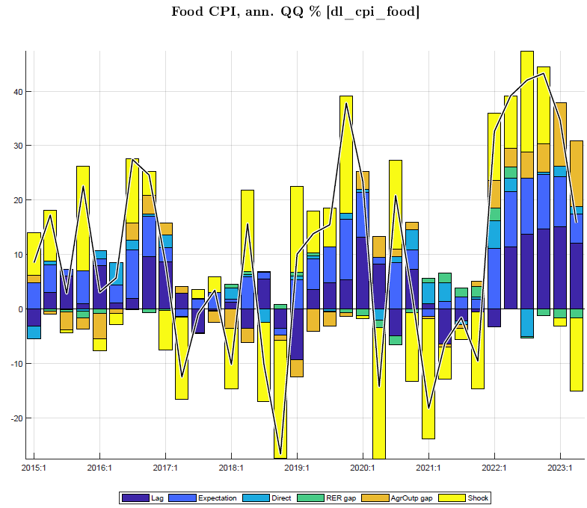 | Fig. 4.8 Drivers of CPI energy inflation  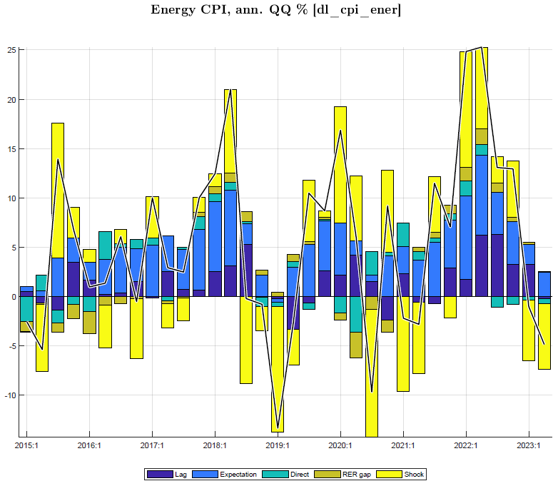

Nominal/real interest and exchange rates
The interbank interest rate (IB) is the rate the NBR seeks to influence through its Central Bank Rate (CBR) and is the indicator of monetary conditions, affecting the RIR and private demand. Therefore, the IB is the “policy rate” in the model. Since 2017 and especially through Covid years 2020-21, the IB was on a downward path and below its trend level of some 6.5-7%. Since 2020, IB and CBR rates have moved more closely, with IB some 0.5% points above the CBR. During 2020-21, despite low inflation and negative output gaps, interest rates were reduced little and were higher than the rates following from the Taylor rule which the NBR seemed to follow (Figure 5.3, positive shocks). In early 2022, in response to the surge in inflation, while the Covid-related negative output gap declined and was perceived to be small, the NBR raised its CBR in five steps, starting in Febr 2022 from 4.5% to 5% and lastly in August 2023 from 7% to 7.5%, and the IB rates have followed closely (Figure 5.1).
The policy RIR (real interest rate, IB minus core CPI expected for next quarter) was below its trend and even negative in 2019 and early 2020. The RIR rose sharply during Covid 2020-21, when inflation was subdued and the IB was lowered only once, by 0.5% to 4.5% in April 2020, in response to the Covid downturn. However, since late 2021, as inflation surged (y-on-y from 1.7% in Dec 2021 to 17% in Dec 2022), the policy RIR and ensuing real lending rate have been falling sharply (Figures 5.2, 5.4).
Figure 5. Interest rates, RIR (IB and lending), and IB historic policy ‘rule’, in %
Fig. 5.1 Interbank and NBR interest rates | Figure 5.2 Interbank rate, Real Interest Rate (RIR) and core inflation

The Taylor interest rate rule followed by the NBR has a relatively small positive (negative) response to output being above (below) potential and a high response to inflation being above (below) target inflation, currently 5% for CPI headline. As NBR moves interest rates gradually, the rule has a heavy weight for the lagged interest rate while trending back to the neutral rate (Figure 5.3). The lending rate has followed the interbank rate, but with a lag and a fairly constant spread of some 9%.
Fig. 5.3 Interest rate (IB) policy rule, components | Fig. 5.4 Real interest rate lending and IB, versus trends
Since mid-2022, the policy RIR has risen sharply as the nominal interest rates were moved up and inflation declined. The real lending rates followed, and after a low point of 7% in mid-2022 reached some 12% by the second half of 2023.

The NBR maintains a flexible nominal exchange policy with intervention to smoothen fluctuations. In practice, NBR’s ER policy can be described by a hybrid rule where the NER is steered such that the RER converges to an implicit target (driven by an exogenous steady-state RER depreciation path, while adjusting for domestic-foreign inflation differentials) and letting it somewhat respond to domestic-foreign interest rate differentials, adjusted for the country risk premium (Figures 6.1-2). Since late 2022, the NER depreciation rate has moved up sharply in line with the target NER depreciation rate—in turn adjusting for the high inflation in Rwanda relative to its trading partners. From early 2023, the speed of depreciation accelerated further, reaching an annualized rate of 16% by mid-year.

Figure 6. Exchange rate, RER, target exchange rate ( “policy rule”)
Fig. 6.1 Exchange rate and target, Q-on-Q % change | Fig. 6.2 Exchange rate, Q-on-Q % change
Fig. 6.3 Exchange rate, target Q-on-Q % change
The RER has fluctuated strongly in recent years, around a slight upward path (of less than 1% per year). In 2019 and early 2020, the RER appreciated (-) as nominal depreciation (+) was insufficient to offset core inflation. In the first half of 2020, nominal depreciation was slowed down as imports fell sharply and aid increased in response to the Covid crisis. From mid-2020, the faster nominal depreciation and subdued inflation more than reversed the earlier RER appreciation. However, from late 2021 till end-late 2022, modest depreciation (around 4% annualized) and the surge in core inflation lowered the RER, to well below trend more than offsetting the earlier increase. The acceleration of NER deprecation since late 2022 resulted in a sharp increase in the rate of RER depreciation (Figures 6.4-5).

Fig. 6.4 RER versus trend RER, q-on-q % change | Fig. 6.5 RER and its components, q-on-q % change

Current macro policy stance and initial condition
Following the review of recent macro developments and policies in Section I, this section recapitulates the current macroeconomic policy stance as of 2023Q4 and the initial conditions for the forecast period 2023Q3—2027Q4.

Current cyclical position
- After the Covid downturn, real GDP has only partially recovered. GDP (output) is estimated to have been below its potential or trend level in mid-2023. After picking up to 11% in 2021, growth slowed to 8% in 2022 and to an estimated 6% in 2023, thwarted by the 2022-23 global shocks related to the war in Ukraine, the associated inflation surge, and the weak agricultural performance, exacerbated by floods in early 2023.

- Output is estimated to have remained below potential since Covid, with a gap of 6% in mid-2023. The Covid lockdowns have not led to loss in capacity or major bankruptcies or permanent effects on human capital or productivity, and potential growth is estimated to remain strong at 7.5% p.y. There is nevertheless uncertainty on the path of potential output post-Covid.

- Private consumption (three-quarters of GDP) has remained below its trend since Covid and dipped further in early 2023 as inflation eroded purchasing power.

- Consumer price inflation (headline q-on-q) was just above 10% in 2023—driven mostly by food and energy prices—on a downward path from its peak of 25.6% in 2022Q2. Core inflation dropped to some 8% so far in 2023, down from a peak of 20.6% in 2022Q2. Food inflation fell steeply to 17%, down from a peak of 56% in 2022Q4. Energy prices fell slightly in 2023Q1-2—after a peak rise by 29% in 2022Q2 but rose in Q3-4 as pump prices were raised.

- With this picture, headline inflation is expected to end at just above 10% in 2023, a significant drop from end-2022, under the combined effect of fading food and core-price shocks and tighter macroeconomic policies.

- Above 10-20% inflation coinciding with GDP below potential in 2022-23 suggests a weak inflation-output gap relationship. Recent inflation is only partly explained by standard factors (output gap (-), import prices (+), weak agriculture (+), and likely reflect other supply-side shocks, such as from varying trade and transport margins and use of monopolistic positions.

Fiscal policy stance
- Fiscal policies are turning from expansionary to contractionary. The policy stance that had been expansionary during and immediately after Covid—with 2% higher deficits (before grants) and especially higher spending on G&S, pulling up output—became less expansionary in FY2022/23, with a deficit reduction from 14.5% to 12% of GDP).

- The current and next budgets have further fiscal consolidation, the brunt borne by spending on G&S, with deficit reductions by about 1% of GDP in both FY2023/24 and FY2024/25.

- Thus, current policies switch the expansionary fiscal stance in 2020-22 to a contractionary one in 2023-25. On average, the fiscal stance switches from the equivalent of +2 % to -2% of GDP with a total effect on output of +/-1.7% of GDP. The effect results from government demand for G&S (direct effect) and the fiscal impulse on private demand (indirect effect).

Monetary and exchange rate policy
- Current monetary policy is modestly tight. The interbank rate at 8% in 2023Q3—resulting from a four-step increase in the CBR by 3% points since 2022Q1—is back up almost to the neutral interest rate. With q-on-q inflation in the 15-25% range during 2022–early 2023, NBR’s interest rate response has been mitigated, as it was perhaps mindful of the incomplete recovery from Covid and increased unemployment since then, and of uncertainty about potential GDP.

- The current real interest rate (RIR-IB) is almost positive. Reflecting increases in policy rate and declines in inflation, the RIR steadily increased from negative since late 2021 (average ─4% in 2022) to almost positive by mid-2023, still below its trend of 3%. In parallel, the real lending rate (with lending premium of 8-9% above IB) is moving up toward its trend level (of 11-12%).

- The increase in RIR has helped stem private demand in 2023, even if consumption and investment have responded little to changes in interest rates. Thus, the relatively weak link from interest rates to demand, combined with a weak link from demand to inflation, make for a weak transmission from monetary policy to inflation.

- Acceleration in nominal exchange rate (ER) depreciation during 2023—from an annualized path of 3-4% in most of 2021-22 to a path of 17% in 2023—has largely offset Rwanda’s recent high inflation relative to trading partners and reversed the overvaluation since late 2021.

- The exchange rate policy has raised the real exchange rate (RER), back to its trend by 2023Q3. This helped reverse the adverse impact on demand for net exports (exports minus imports) in 2021-22, and net exports are favorably affected by the RER from 2023Q3 onward.

- While the post-Covid RER overvaluation has been reversed, the need for further RER depreciation depends on the assessment of the degree overvaluation that existed pre-Covid or emerged from changes in fundamentals since then (such as a structural decline in grants).
Overall macro policy stance
Modestly tight monetary policy, fiscal consolidation in 2022/23 reinforced with the FY2023/24 Budget, and exchange rate policy entailing initially some overvaluation have helped contain domestic demand and bring inflation down in 2023, and should continue doing so in the near future. As and when inflation (shocks) abates, there would be room for policies that raise GDP growth back to its potential level, stabilize the fiscal deficit at its sustainable level, and stabilize the RER.

Macroeconomic outlook, end-2023─end-2027
This section presents the 16 quarter ahead forecast, using model and initial conditions, as updated with full data for 2006Q1 through 2023Q2 and with parameters recalibrated (Sections I-II). It first highlights the underlying external and domestic environment assumptions, then sums up the macroeconomic outlook, and lastly provides a narrative for key macro forecast variables. Alternative scenarios are discussed in Section IV.

Forecast assumptions

External environment assumptions (WEO and other sources)
The overall outlook is improving after the Covid-Ukraine crises, but with downside risks (Figure 7).
The world economy is slowing down due to world interest rate increases in response to inflation,
but Rwanda still enjoys a recovery in foreign demand relative to Covid-years 2020-21—with trading partner demand growth at over 4% per year. World food and oil prices likely peaked in the second half of 2022 and are projected to gradually return to their trend levels, though food prices are projected to stay high for several years (Figures 7.1-3).
Figures 7.1-3 External environment (WEO-GAS/ GEE)
World real interest rates are expected to rise from negative around -1% in the past decade to +1% by 2027, with the increase likely transmitting one-for-one to Rwanda’s sovereign borrowing rates.
Trading partners’ CPI inflation (in US$)—subdued at 1.4% p.y. during 2016-22 before flaring up in 2023—is projected to return to its trend level of 2% in the coming years (Figures 7.4-5).

Table 2. Rwanda’s external environment in recent years, y-on-y % growth (unless indicated otherwise)
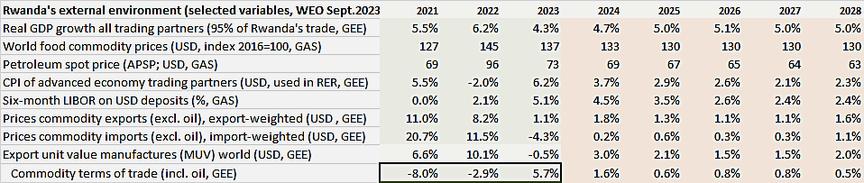
Figures 7.4-5 External environment (WEO-GAS/ GEE)
Trading partner CPI:
advanced economy partner CPI in US$;
fluctuations also reflect currency movements in vis-à-vis US$

Domestic environment assumptions
For the key macro variables, medium-term trends are derived from historic data and judgment about steady states. These trends underpin the forecast for potential GDP and final demand components; structural deficit and constituent parts (revenue, demand for G&S and other spending; all in percent of GDP); the trend (neutral) nominal interest rate and trend RIR; and trend RER depreciation rate.
For some macro variables, the forecasts for nearby quarters are ‘tuned,’ i.e., set using near-term forecasts available from other tools, expert judgment, and provisional estimates. E.g., GDP in current and next quarter is set using the now/forecasting tool, the current-quarter CPI and its components are estimated based on latest months’ provisional data. Another assumption on the domestic environment is that recently observed shocks disappear, e.g., agriculture normalizes and food and core price shocks are abating.
Other variables are tuned using known or expected policies and judgment. E.g., the NBR’s interest rate or the next-quarter monetary policy committee meeting is guessed (no change) and the exchange rate for the one or two quarters is set based on statements and the program with the IMF.

Fiscal policy assumptions
Fiscal policies are part of the domestic environment but as they are known (Budget Law) or expected (MTBF, program with IMF) and are crucial for the forecast, the forward fiscal policy stance is elaborated here. The post-Covid consolidation and winding down of crisis-related spending since 2021/22 continues with the 2023/24 Budget, with a further reduction in the deficit before grants to 10.8% of GDP in 2023/24, and 9.7% in 2024/25 (Table 3). After the PCI-program years, fiscal deficits move back to the sustainable path (of 8% of GDP), based on target debt/GDP ratios (see Section C.3).
Table 3. Fiscal policy 2023/-2024/25 under PCI (% of GDP) | 2018/19 | 2019/20 | 2020/21 | 2021/22 | 2022/23  est. | 2023/24  PCI | 2024/25  PCI | 2025/26  post- | 2026/2  PCI pro- | 2027/28  jection
Deficit (before grants, GFS-1986 def.) | -10.8% | -13.6% | -14.1% | -14.5% | -12.0% | -10.8% | -9.7% | -7.9% | -6.7% | -5.2%
Revenue (tax & non-tax, excl. grants) | 19.2% | 18.8% | 19.5% | 19.0% | 17.6% | 17.8% | 18.3% | 19.3% | 20.2% | 22.4%
Expenditure G&S (cons & invest) | 26.2% | 26.1% | 27.5% | 26.7% | 24.4% | 23.4% | 22.8% | 22.4% | 22.4% | 23.0%
Other spending (subs.-transf.-net lend) | 3.8% | 5.5% | 5.8% | 6.8% | 5.2% | 5.2% | 5.2% | 4.7% | 4.5% | 4.6%

Summary of macroeconomic forecast
As noted above, forecasts are tuned for nearby 1-2 quarters for output, inflation and components, interest and exchange rate, and fiscal deficit variables. For inflation, forecasts are from model equations, but with shocks added in the belief that recent inflation shocks not explained by demand pressure (proxied by output gap) continue for another quarter, e.g. core inflation (Table 4). All other forecasts, except external environment variables, are endogenously determined by model relationships.

Table 4. Tuned variables |  | 2023Q3 | 2023Q4 | 2024Q1 | 2024Q2 | 2024/25
GDP now/forecast for leading indicators | y-on-y growth | 5.2% | 5.0% | -- | -- | --
CPI headline | y-on-y growth |  | 9% |  |  | --
CPI_core shock | q-on-q % ann. change |  | 6% | 1% | -- | 1%
CPI_food shock | ,, |  | -- | -- | -- | --
CPI_ener shock (restore excise 2023Q3) | ,, |  | 1.5% | -- | -- | --
Policy rate (interbank rate) | (½ % above CBR) | 8.0% | 8.0% | -- | -- | --
Exchange rate | RWF/US$ | 1195.5 | 2.7% depr. | -- | -- | --
Fiscal deficit (before grants, GFS1986) | % of GDP | 9.8% | 9.8% | 11.8% | 11.8% | 9.7%
The main forecast results are summarized in Table 5.
Table 5. Forecast summary: main indicators
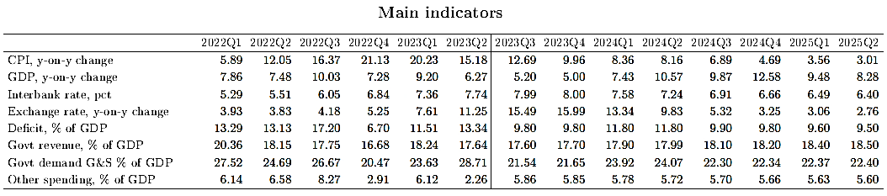

Inflation—after its peak in 2022Q4, is forecast to continue declining in 2023 and drop below 5% in 2024Q4 as food price inflation abates (prices drop in late 2024) and core inflation returns to its trend.
GDP—the slowdown induced by recent inflation and restrictive policy response in 2023-24 is expected to continue until 2024Q1. Henceforth, output growth should pick up to above 10% until early 2026, helped by temporarily somewhat less restrictive monetary and fiscal policies (Figures 8-9).
Figure 8. Summary forecast: output, inflation, RIR and RER
Fig. 8.1 Output growth | Fig. 8.2 Inflation headline |  | Fig. 8.3 Real interest rate | Fig. 8.4 Real exchange rate
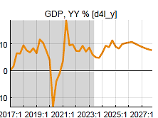 | 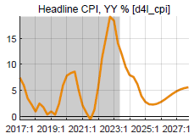 | 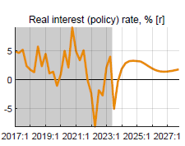 |  | 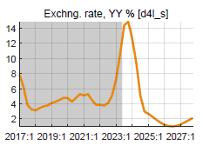
The temporary above-trend growth for two years from mid-2024 is mostly driven by private consumption and return to normal of government demand.
Figure 9. Summary forecast: main drivers of growth (Y-on-Y % and % of GDP)
Fig. 9.1 Private consumption | Fig. 9.2 Gov demand for G&S | Fig. 9.3 Budget deficit excl. grants | Fig. 9.3 Exports
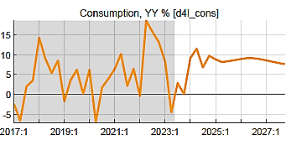 | 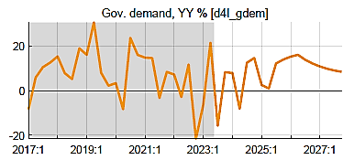 | 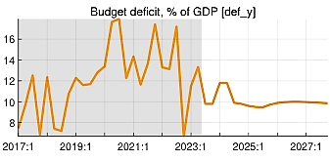 | 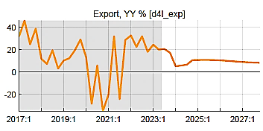

Macroeconomic forecast narrative

Output (GDP) and cyclical position
The y-on-y growth of output (GDP) is expected to remain sluggish at 5% in 2023Q3-4 given the restrictive fiscal and monetary policies. The reduction in budget deficit and government spending and the drop in real incomes as inflation soared has translated in a drastic drop in real demand.
From 2024Q2, output growth should rise to above trend for 10 quarters (10% on average) helped by still low RIR interest rates and higher RER. Fiscal policy is forecast to remain unchanged after 2024/25, i.e., no further consolidation is forecast from 2025/26 and only a very gradual reduction in the deficit toward the level deemed sustainable of 8% of GDP. From 2027 onward, output returns to its potential trend growth of 7.5% per year. Rend growth is assumed unchanged after the Covid crisis, since no production capacity, human capital or productivity have been permanently lost.
2022-24 sluggish growth, driven by:  --consumption recovery from Covid interrupted by Ukraine-war and inflation surge and restrictive policy response  --post-Covid fiscal consolidation with negative fiscal impulse  2024-26 growth above trend, driven by:  --less restrictive fiscal policies as deficit gradually back to (higher) sustainable level and govt demand for G&S back to normal  --exports helped by high RER  From 2027, back to trend growth of 7.5%  --there is no indication that Covid has permanently reduced poterntial output and its growth | Figure 9.1 GDP growth and its demand components
Contributions of final demands to growth, weighted with shares in GDP;
consumption (78%) and govt demand (23%) have largest contributions
GDP is estimated to be 7% below potential at end-2023, due to both incomplete recovery from Covid and sluggish growth in 2022-23. Output growth is expected to be a bit faster than trend in 2024-26 as the remaining output gap is reabsorbed by the full recovery of consumption and the gradually disappearing down pull from the post-Covid below-trend government demand.
Figure 9.3 Output-below-potential (negative gap) and its components
Negative output gap declines gradually:
--lessening down pull from consumption which goes back to normal
--large initial down pull from reduction in real government spending
--but gradually disappearing from mid-2024
--exports helped by increasing REER

The growth of the final demand components of GDP are shown in Table 6, highlighting the relatively sharp fluctuations in the post-Covid period, especially in investment, by mid-2025 all final demands (except government) are converging to their steady state growth rates.
Table 6. Final demand components of GDP, Y-on-Y growth rates, in %
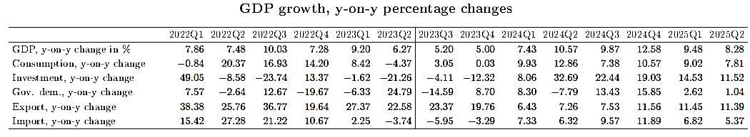

Private final demands and cyclical position
Private consumption is expected to recover from recent low levels but remains restrained in 2024 by low GDP growth and negative fiscal impulse in 2023-24. After that, as fiscal, and to a lesser extent monetary policy, becomes less restrictive and output growth picks to above-trend, it should return to trend growth in late 2026.
Figure 10. Consumption growth and gap
Fig. 10.1 Consumption growth and trend | Fig. 10.2 Consumption gap and its components
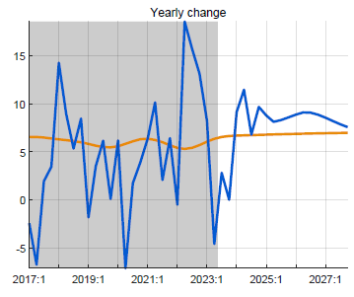
Consumption back to trend, drivers:
--persistence, lagged effect
--expectations
--income, proxied by real GDP
--negative fiscal impulse

The other final demand components—contributing much less to GDP—have their own drivers.
Figure 11. Export gap and components
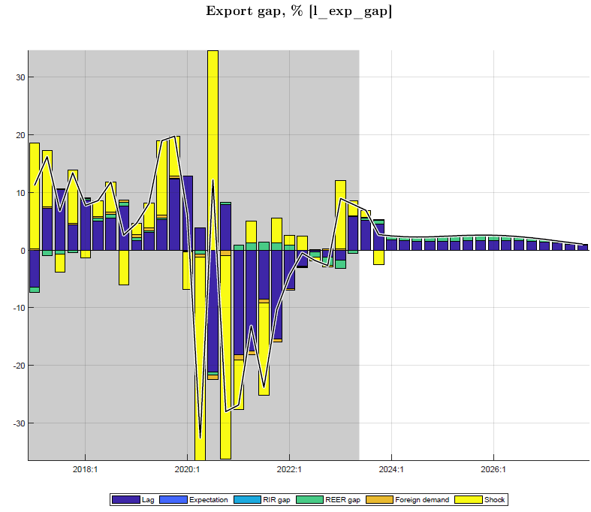 | Exports return to trend level and growth path:  Main drivers:  --persistence (lag)  --expectations  --foreign demand (mainly relevant for tourism, albeit with small coefficient)  --down pull from RER overvaluation disappears

Figure 12. Private investment gap and components
Private investment returns to trend level and growth path
Main drivers:
-- persistence (lag)
--expectations
--real interest rate (RIR) effect is very small
--RER has no effect (zero wight in monetary conditions index)
--small income, effect (proxied by real GDP)
--fiscal impulse has very small effect

Figure 13. Import demand gap and components
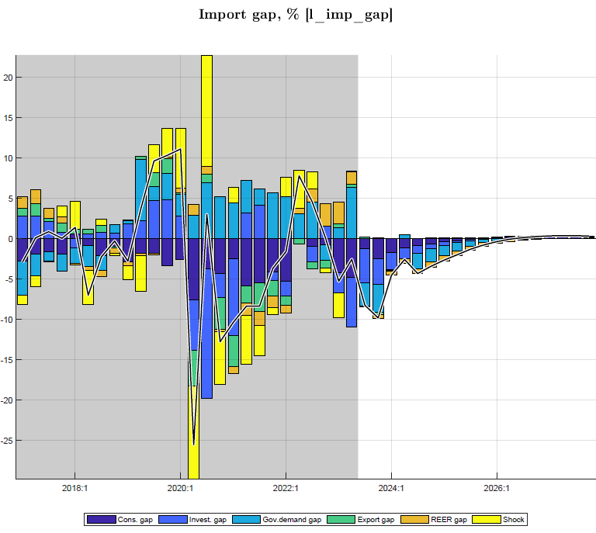 | Import demand (for goods and services) returns to trend level and growth path:  Main drivers:  --final demand components, esp. consumption, govt demand, investment  --RER effect reverses to negative as real depreciation (lower overvaluation) reduces imports

Fiscal policies and government demand
Fiscal policies affect output mostly directly as government spends on G&S, and to a smaller extent indirectly as fiscal deficits affect private demand. For 2023/24-2024/25, forecasts are tuned to be in line with the fiscal consolidation program with the IMF, and show a sharp reduction in deficit (before grants) and spending on G&S, as discretionary spending is reversed from Covid-years (Figures 14.1-2). The annual deficit is tuned at 10.8% of GDP in 2023/24 and 9.7% of GDP in 2025/26, down from 12% of GDP in 2022/23.
Beyond the tuned PCI-program years, i.e., from 2025/26 onward, fiscal deficits and their constituent parts (revenue, spending,…) are forecast to gradually move to their structural levels, as determined by tax policies and sustainable debt-GDP ratios, with a sustainable deficit (before grants) of 8% of GDP, i.e., sustainable debt-creating deficit of 5% and sustainable grants of 3% of GDP. Thus the QMFM does not follow the post-PCI fiscal projection, which much overshoots Rwanda’s debt/GDP anchor, as stated in the PCI. Instead, the QMFM fiscal path is consistent with the PCI debt/GDP anchor.
Figure 14. Government deficit and constituent parts and components, % of GDP
Figure 14.1 Deficit: revenue (-), spending G&S (+), and other spending (+) | Figure 14.2 Structural, cyclical, and discretionary deficit, % of GDP

Government demand. The current fiscal program envisages a reduction in the deficit to 10.8% of GDP in 2023/24 and to 9.7% in 2024/25, well below that in Covid and immediate post-Covid years (averaging 14% of GDP in 2019/20-2021/22). This is achieved mainly via the ending of discretionary, crisis-related spending and cuts in investment, which translate in a significant reduction in real government demand for G&S, lowering aggregate demand and helping contain inflation. The expansion of discretionary government demand for G&S to offset the drop in output in the Covid years is thus reversed from mid-2022 (despite a partial flare-up in 2023Q1-2), and the large negative effect is forecast to last till early 2026 (Figures 15.1-2).
Figure 15. Government demand: as ratio of GDP and gap vis-à-vis trend
Fig. 15.1 Govt demand for G&S and trend, % GDP  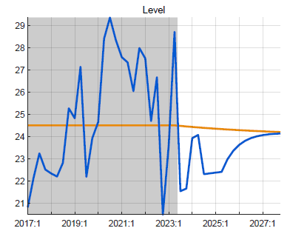 | Fig. 15.2 Govt demand gap (vis-à-vis trend) and drivers, in %

Fiscal impulse onto private demand. The “fiscal impulse” (deficit affecting private demand and hence output indirectly), positive on average in 2020-22, turns negative from late 2022 onward and remains so for several years before fading out by 2027 (Figure 15.3).
Fiscal stance total effect on output. The combination of lower government demand for G&S and a negative fiscal impulse onto private demand are forecast to have an important negative effect on output during 2023/24-2025/26 (Figure 15.4). An average negative discretionary deficit of 1½% of GDP is estimated per se to lower real GDP by some 1.2%, mainly from lower government for G&S (two-thirds) and the remainder from lower private demand.
 | Fig. 15.3 Components fiscal impulse, onto private demand, % GDP | Fig. 15.4 Fiscal stance: effect on GDP via govt demand and private demand, % GDP

The discretionary deficit, on average positive, expansionary during 2020-22, turns negative, contractionary during 2023-26, mainly from government spending on G&S (Figure 16.1). The latter has been its main driver, and it is in this category that there is most room for discretionary policy, much more than for revenue and other spending (transfers and subsidies).
The cyclical deficit is slightly positive during 2023-26, mainly from revenue being below trend due to the lingering output gap and the lagged adjustment of taxes and fees to the recent surge in inflation (Figure 16.1).
Figure 16. Discretionary and cyclical deficit 2023-27, % GDP
Fig. 16.1 Discretionary deficit, % of GDP | Fig. 16.2 Cyclical deficit, % of GDP

Inflation (CPI)
Consumer price inflation (headline q-on-q) (having peaked in 2022Q2) is forecast to continue declining but with a modest flare-up in late 2023/early 2024. The flare-up results from food price shocks in Q4, the pump price increase in October, and the passthrough of the exchange depreciation in preceding quarters. From 2024Q2, inflation should decline below 5% reflecting a modest drop in world food and oil prices, improved domestic food supply, and fading of earlier shocks (Table 7).
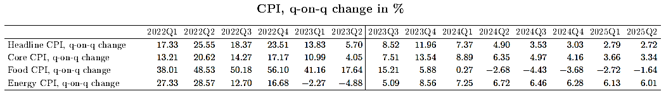

The sharp drop in q-on-q inflation translates into a more gradual drop in y-on-y inflation (which peaked in 2022Q4). The largest contribution comes from the moderation in food price increases, even with a short period of falling prices (Figure 17.1-2).
Figure 17.1 CPI headline (Q-on-Q) and its decomposition (Y-on-Y), %
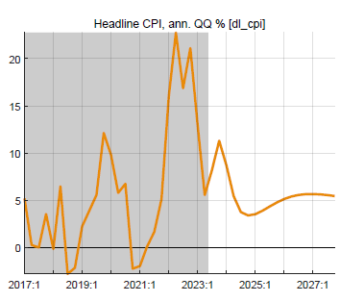

Figure 17.2 Inflation components: core, food, and energy, Q-on-Q annualized, %)
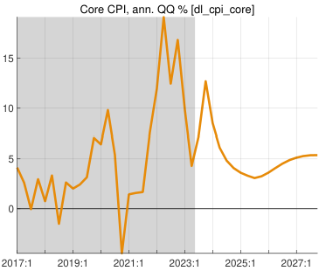 | 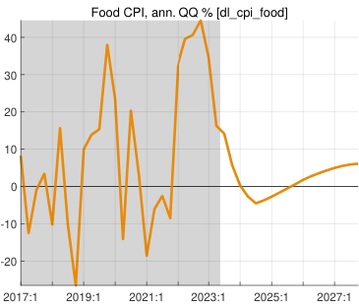 | 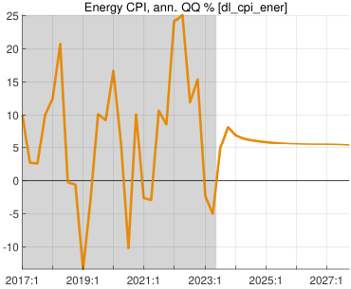

The core inflation forecast of a gradual drop is driven by inflationary expectations, small upward direct effects of import prices and REER (both reflecting exchange rate depreciation), a small downward effect of persisting post-Covid negative output gap, and the gradual subsiding of shocks, tuned to last for only 2023Q4 (Figure 18). Core inflation rate falls slightly below its target of 4.5% in mid-2025 due to the down-pull from remaining negative output gap, then somewhat overshoots 2026-27 (to.5.5%) as a small positive output gap emerges.
Figure 18. CPI core and its drivers, Q-on-Q annualized, %
Main drivers :
--expectations
--persistence (lag)
--direct effect of import prices (+) (foreign prices, exchange rate)
--REER (+) as faster ER depreciation leads to positive RER gap
--output gap (-) exerts small downward pressure

The food inflation forecast of a rapid drop (from a peak in 2022Q4) is mainly driven by declining negative agricultural output gaps (which in part drove prices up from late 2021 to late 2023), as agriculture is expected to normalize. The direct effect of imported food prices is upward (due to ER depreciation), and the indirect effect of the food RER gap is downward (as world food prices are fell back below trend). Shocks, already small in 2024, are forecast to subside in the near term (Figure 19).
Figure 19. CPI food and its drivers, Q-on-Q annualized %
Figure 19.1 CPI food inflation and its drivers, q-on-q annualized, % | Figure 19.2 Agricultural output gap, %

Figure 19.3 Direct effect of imported food prices on CPI food, Q-on-Q %
Main drivers:
--foreign food prices continue to decline or being below trend durin 2023-26
--ER depreciation raises domestic food prices

The energy inflation forecast of a rapid drop (from a peak in 2022Q2) is driven in by the direct effect of imported energy prices which are projected to fall throughout 2023-27, although the pass-through to domestic energy prices is attenuated by lags and offsetting adjustments in domestic fuel excises. The exchange rate depreciation exerts some upward pressure, but little compared to that of foreign energy price drop. Shocks, typically large and especially so in 2022-23, including reflecting the Oct 2023 pump price increase, are projected to disappear from 2024Q1 (Figure 20).
Figure 20. CPI energy, q-on-q annualized, %
Figure 20.1 CPI energy and its drivers | Figure 20.2 Direct effect of imported energy prices on CPI energy

Policy interest rate and real interest rate
The IB rate (or “policy rate” NBR aims to influence with its CBR) is forecast to be gradually lowered from its peak of close to 8% in August 2023 to around 6½% in late 2024 in line with the decline in CPI inflation and output estimated to be still below potential (negative output gap). From 2025, the IB rate is pulled back toward its trend or neutral level of about 7.5% (Figures 21.1-2).
Figure 21.1 Interbank interest rate, %
--IB rate is tuned for Q4 2023, assuming NBR would keep its CBR unchanged from August 2023
--the IB is about 0.5% points above the CBR (equal to repo rate; CBR not shown separately)
--for 2024, the model’s policy rule forecasts a gradual reduction in IB rates, as inflation drops below the 5% target and a negative output gap remains
--from mid-2025, the IB rate moves back up to its trend or neutral level (7%), determined by trend foreign RIR (0-0.5%), country risk premium (2%), and core inflation target (4.5%)

Figure 21.2 Drivers of interbank interest rate (policy rule)
Drivers of policy rule in 2024:
--expected inflation deviation from target (-)
--negative output gap (-)
--pull from neutral interest rate (7%) (+)
--gradual interest rate changes, (lagged effect)
The policy real interest rate (RIR) is influenced by NBR’s CBR rate with a view to steering private demand. After a significant drop into negative territory since early 2021 due to high inflation and lagged interest policy response, the RIR is forecast to continue its rise that started late 2022, as nominal interest rates rise and inflation eases. Yet the RIR is forecast to remain below its trend level of 2-2.5% and even slightly drop in mid-2025 as inflation flares up temporarily due to demand pressure from fiscal expansion (Figure 22).
Figure 22. Real interest rates, %
Fig. 22.1 RIR (IB rate) and trend, % | Fig. 22.2 RIR (IB rate) components, %
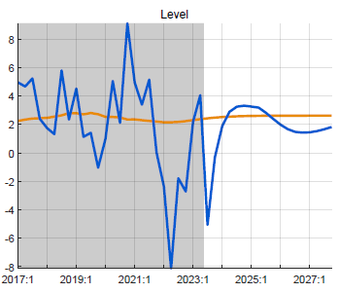
The movement in the RIR (as affected by NBR policies) is transmitted to the real lending rate for private demand, calculated as the forward average RIR(IB) over 4 quarters plus a time-varying lending premium (+ 9% points above the IB rate). The real lending rate—above trend during Covid and much below trend, even negative, when inflation surged in 2022-23—is forecast to rise to close to its trend level in 2023, with a depressing (increasingly less positive) effect on private demand.
Fig. 22.3 Real policy and lending rates and trends,% | Fig. 22.4 Real interest rate (RIR) trend, %  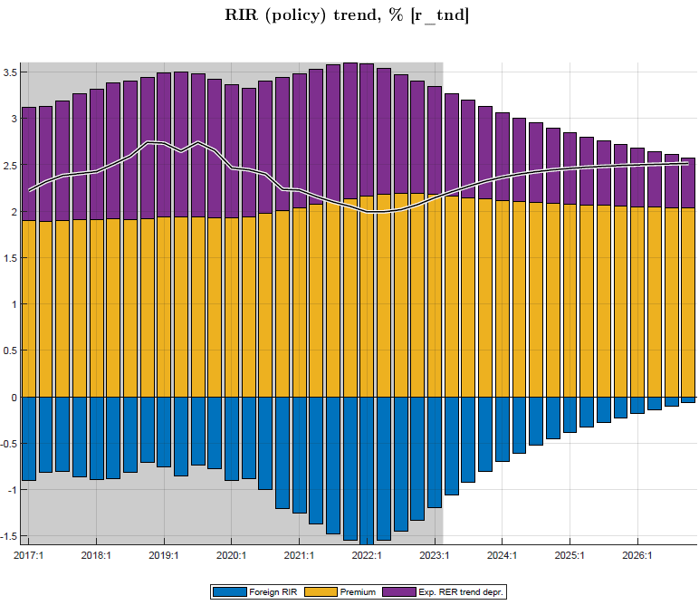

Exchange rate (ER) and real exchange rate (RER)
The forecast reflects NBR’s flexible exchange rate policy and its hybrid rule in practice which is steering the ER to the target ER such that the RER gradually matches the target depreciation rate. In addition, the ER responds somewhat to interest rate differentials (adjusted for country risk premium). The ER is forecast to continue its recent fast depreciation path (annualized 15% for most of 2023), a bit faster than indicated by the target ER, correcting for the recent overvaluation due to high domestic inflation. It then returns gradually to the target ER depreciation rate as explained next (Figure 23).
Fig. 23. Exchange rate “policy rule” and ER target, Q-on-Q annualized, % change
Fig. 23.1 Exchange rate “policy rule” (Q-on-Q, %) | Fig. 23.2 ER and target
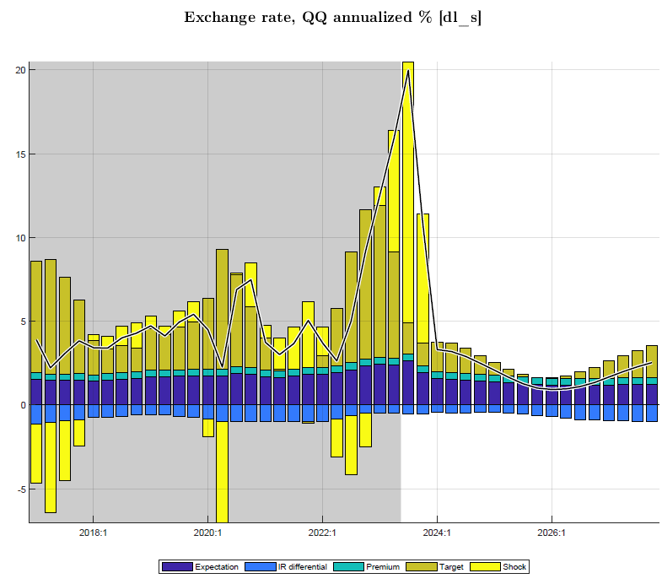 | --ER tuned for 2023Q4 using stated policy of NBR for 2023  --ER steered toward target, so that RER matches trend depreciation rate  --some response to interest rate differentials

The target ER is forecast to descend from its recent faster depreciation rate (as NBR accelerated depreciation during 2023) and return gradually to its trend, which is entirely driven by the difference between target domestic and foreign inflation rates (some 2.5% p.y.) and the trend RER depreciation rate (estimated at 0% p.y.). In addition, the target ER responds to a RER gap (with a negative coefficient) so that the ER is made to adjust faster to overvaluation (negative RER gap as is currently the case) or an undervaluation.
 | Fig. 23.3 Target exchange rate depreciation rate (Q-on-Q, %)
Drivers ER target:  --domestic-foreign inflation differential (target CPI-core minus trend CPI*, + 2%)  --trend RER depreciation rate (0% p.y.) | 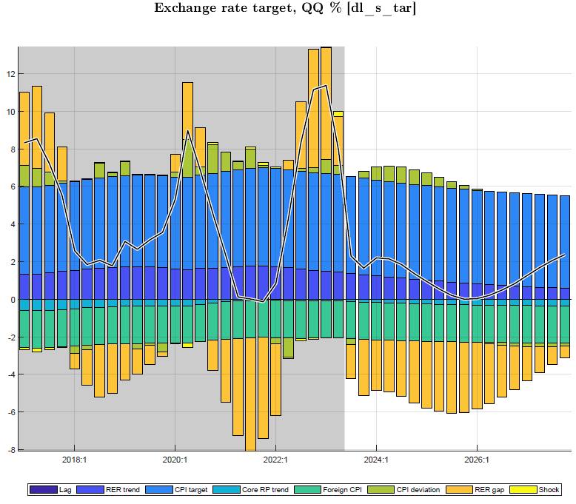

The real exchange rate (RER) is forecast to see a slowdown in the pace of depreciation (from its high in 2023) to return gradually to its (zero) trend level. The RER overvaluation induced by the 2022-23 inflation episode continues to be reduced and is forecast to be close to zero from 2024. The sharp upward correction in the RER is forecast to favorably affect net exports and demand (reversing a sharp RER decline during 2021-22) (Figure 24).
After a somewhat overvalued RER had a downward effect on net exports demand in 2021 when the economy emerged from Covid, it is forecast to rise to its trend level (with some overshooting in 2024) and to affect demand favorably in 2023-24.
Figure 24. Real exchange rate and components, annualized q-on-q, % (vis-a-vis CPI core)
Fig. 24.1 Real exchange rate, trend and gap, in % | Fig. 24.2 Real exchange rate versus trend, in log-level  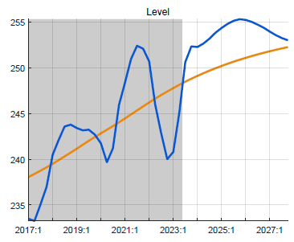
Fig. 24.3 RER, nominal ER, foreign CPI*, and domestic CPI_core, Q-on-Q annualized, in %
Components RER:
--temporarily accelerated nominal depreciation
--domestic core inflation subsides
--foreign CPI* returns to its trend (2-2.5% p.y.)

Summary of policy stance and forecast
This study derives macro forecasts using a gap model, calibrated with data for 2006Q1─2023Q2. The initial conditions, policies, model policy rules, and behaviors and interactions generate a simultaneous forecast of key macro aggregates: paths for inflation and its components, output and final demands, deficit and its components, and indicators for fiscal, monetary, and exchange rate policies.

The forecast is conditional on exogenous assumptions and tuning. These are WEO forecasts for external variables (e.g., foreign prices, demand,..); domestic trends (e.g., GDP, real interest rates,..) as derived from data and judgment; near-term now/forecasts or estimates from other tools, sources or judgment (GDP, CPI, shocks,); and known or expected fiscal policies (deficit, revenue, spending) for two fiscal years and monetary and exchange rate policies for current and possibly next quarter.

The forecast starts from latest the data and current policy stance as of 2023Q3. Current fiscal policies are tight with the consolidation program for FY2022/23─FY2024/25 after the Covid-related expansion. Monetary policy is modestly tight, as policy rate and real interest rates are moving back up to their neutral and trend levels, resp. On the other hand, exchange rate policy of accelerated depreciation removed the earlier real overvaluation and is starting to raise demand for net exports.

Table 8. Summary forecast indicators
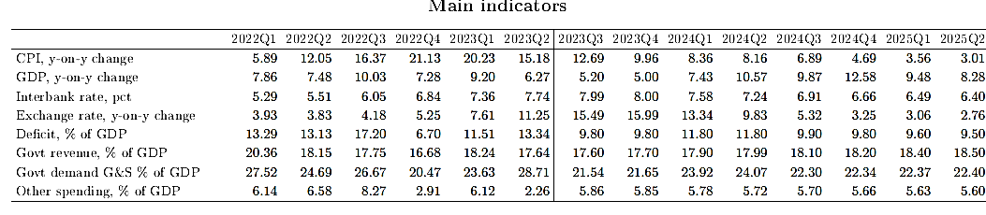

Fiscal impact. The planned reduction in fiscal deficits for FY2023/24─2024/25 (to an average of 10.2% of GDP from 13.5% in FY2020/21-2022/23) entails a drop in government demand for G&S of similar magnitude and exerts a negative effect on private demand. This fiscal stance is forecast to impact total demand and output negatively in the order of 1.2% of GDP.

Interest rate and RIR. The interbank (IB) rate is forecast to be gradually lowered from 2024Q1 onward, in line with the declining inflation and remaining output gap, then move back up to the neutral interest rate estimated at some 7.5%. The RIR is forecast to continue its recent rise as inflation drops, then fall as the IB rate responds to output gaps, before moving slowly back up to its trend level (of 2.5%) beyond the projection period. The RIR impact on private demand is initially negative, then positive for 10 quarters, before going back to neutral after 2027.

Exchange rate and RER. The nominal exchange rate is forecast to gradually return to a less fast depreciation path of 3-4% per year (down from 17% in 2023), since the recent overvaluation has been reversed, and the exchange rate policy rule mainly adjusts for inflation differentials. In 2024-25, this RER path is much below the PCI program path. The RER is forecast to show a decelerating pace of depreciation (from its high in 2023) to return gradually to its trend level (and zero trend depreciation rate) from 2025. The sharp upward correction in the RER should favorably affect demand for net exports in 2023-24, but the effect should fade out thereafter.

Inflation. Consumer price inflation (headline, q-on-q) is forecast to continue its recent gradual decline, but with a modest flare-up in late 2023/early 2024 resulting from food price shocks in Q4, the pump price increases in October, and passthrough of the strong exchange depreciation in preceding quarters. From 2024Q4, inflation should decline a bit below 5% reflecting modest drops in world food and oil prices, improved domestic food supply, and fading of earlier shocks. As a result, CPI inflation headline y-on-y should be close to 5% from 2024Q4 on.

Output. Real GDP growth (y-on-y growth) is expected to remain sluggish in 2023Q3─2024Q1. It is forecast to rise to above trend for 10 quarters (almost 10% on average) helped by temporarily lower nominal and real interest rates and higher RER. The output gap (GDP below potential, estimated at -7% at end-2023) should dissipate by early 2026 and output growth returns to its trend of 7.5% p.y.

Overall. The combination of modestly tight fiscal and monetary policies and still low RER in 2023 and early 2024 should help contain domestic demand and lower inflation. As inflation abates to close to the 5% target from 2024Q2, the temporarily lower interest rates and RIR and higher RER should raise GDP growth temporarily above its trend in 2024-25, and back to its trend from 2027.

Supplementary information

Comparison with Macroeconomic Framework projections
An illustrative comparison with Nov. 2022 projection (PCI) shows that annualized QMFM result has—compared to MF:
- lower volatility in final demand components, especially for consumption, investment, and imports (MF anomalies…)
- higher average CPI inflation in 2023, more accurate as it traces inflation by quarter
- lower ER depreciation from 2024, as it forecast zero RER depreciation in MT, the MF has real depreciations each year in 2024-26
- higher fiscal deficits return to sustainable level, whereas PCI reduces deficit much below
- correctly reproduced historic data.

Table 3. Comparison annualized QMFM forecast with annual intMF projections (Nov.2022) to UPDATE
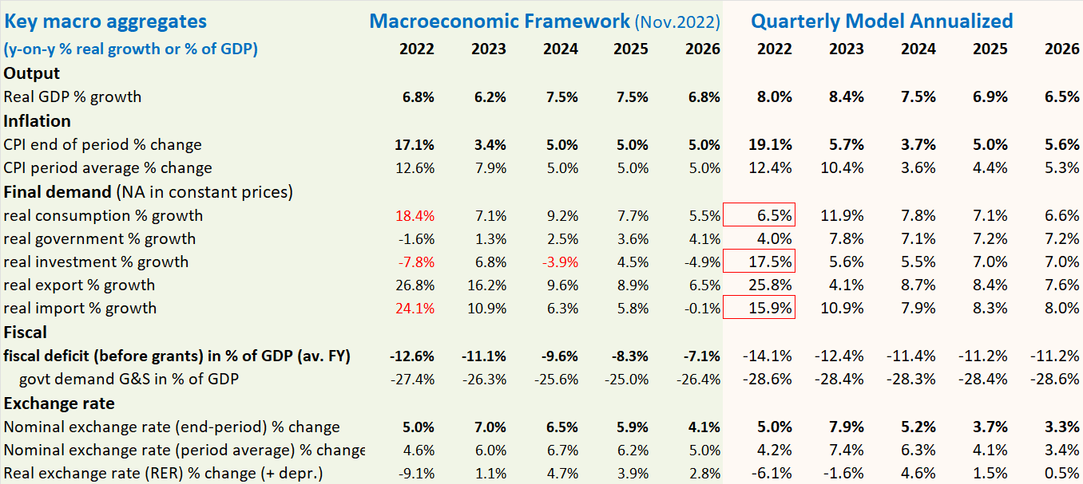

Alternative scenarios and policy responses
This section discusses alternative scenarios to the Baseline underlying the Outlook Forecast Section II.
The forecast model is particularly useful for generating alternative scenarios for comparison with the Baseline (BL). The BL scenario embodies broadly appropriate policy responses to the current external and domestic environment and reflects best judgement on near-term forecast for key variables. But on each front, it is important to explore sensitivity to changes in exogenous variables and domestic policies. This is illustrated in the following scenario.

Scenario of higher foreign food and oil prices in 2023-24 to be updated
For 2023-24, foreign food and oil prices are set at levels on average 25% higher than in the baseline (WEO-GAS price projection in US$, Figure 7 above).
Figure 25.1 Foreign food and oil prices are simulated higher in 2023-24, return to WEO levels from 2025
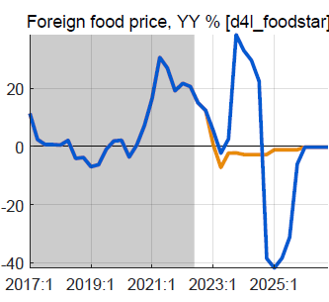 | 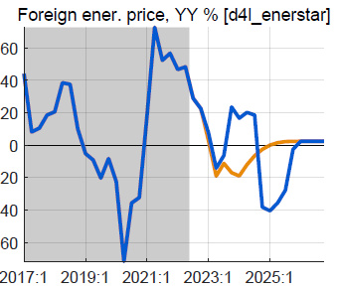
Domestic food and energy inflation remain higher for several quarter, but this is reversed as foreign prices return to the BL from 2025. The effect on upward on headline inflation is small, and also reversed later.
Figure 25.2 Domestic CPI inflation is higher, reflecting import shares in food and energy components
.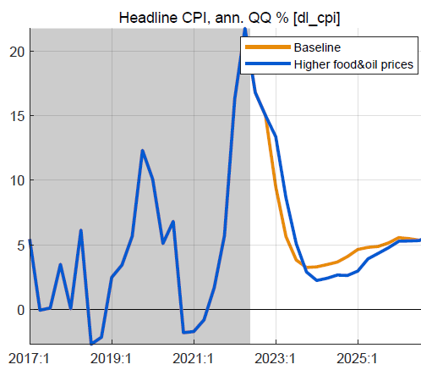 | 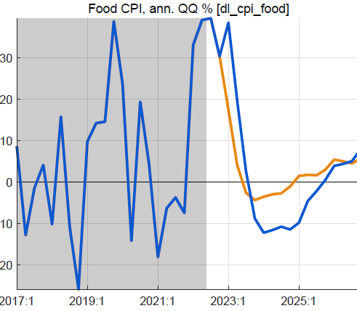 | 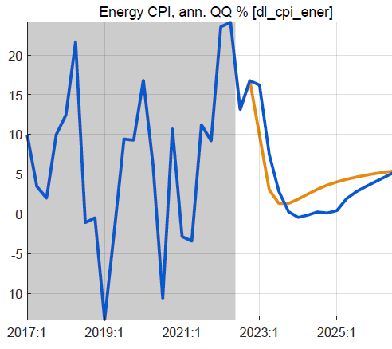

Figure 25.3 Small response policy rate, reversed quickly | ….RIR lower than in baseline | ….tiny positive real output effect, due to RIR but mostly | offset by effect of slight RER appreciation
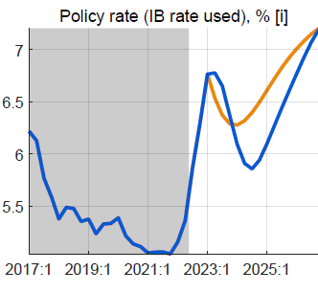 | 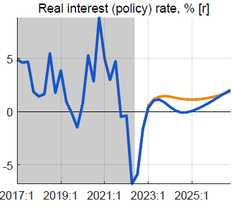 | 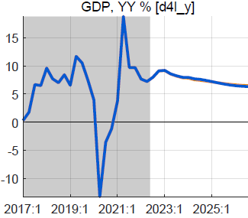 | 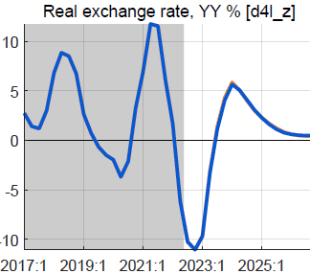
The response of the policy rate in 2023 Q2 is small as the foreign inflation impulses are temporary, and do not affect inflation expectations. The increase relative to BL is reversed in 2024 as the expected inflation becomes lower than in the BL.
With the small increase in the core CPI, the RIR is a bit lower, with a positive impact on consumption and investment. The nominal exchange rate appreciates slightly vis-à-vis the BL when the policy rate is raised; this reverses quickly, but not enough to avoid a slightly more appreciated RER than in the BL, with a negative effect on net exports. The overall impact on GDP is very small, less than 0.2%.

Possible domestic policy response
The scenario focuses on the impact of higher foreign prices and does not incorporate a fiscal policy response. A possible policy response could be temporarily higher budget transfers to protect vulnerable households against higher domestic food and energy prices.

Annex 1. Rwanda Quarterly Macro-Fiscal Model (QMFM) main features
The QMFM builds on the extensive theoretical and empirical literature on FPAS models typically used by central banks but also ministries of finance, and greatly expands the fiscal policy component.
It has the key features of FPAS models (which are simplified New-Keynesian DSGE models):
--founded (albeit loosely) in microeconomic theory, i.e., the neoclassical real business cycle theory and intertemporal optimization for households and firms, with added-on price setting (market power) and adjustment costs, and with forward-looking, model-consistent expectations
--incorporating endogenous monetary and fiscal policies and policy rules, aimed at price stability and output stabilization, with scope for discretion to respond to crisis and shocks
--having four main blocks: for demand, supply (prices), exchange rate, and interest rate (Table A1.1); the QMFM also has a block for fiscal policies and blocks for money and external flows (see below).
Table A1.1: Main macroeconomic variables in Quarterly Macro-Fiscal Model
Dependent variable | Equation: main variables^{1/ 2/} | Data frequency | Source | Latest data
1. Real GDP | 1. Demand-output  Real interest rate, fiscal impulse, | Quarterly | NISR | Q2 2023
1a. Macro demand components  (Cons, Inv, Govt, Exports, iMports) | income, foreign demand,  real exchange rate | Quarterly | NISR | Q2 2023
2. CPI Core inflation (and food, energy, headline) | 2. Phillips curves:  output and RER gaps | Monthly, Q | NISR, NBR | Nov. 2023
3. Exchange rate (RWF/USD) | 3. UIP & move to target ER:  interest rate, foreign interest rate, country risk premium, equilibrium RER change, inflation target, foreign CPI | Monthly, Q | NBR | Nov. 2023
Real exchange rate (affecting  (demand), country premium |  | Monthly, Q | NBR | Nov. 2023
4. Policy interest rate  Interbank (IB) rate used, influenced by NBR’s CBR | 4. Taylor policy rule:  output gap inflation deviation, equilibrium RIR, inflation target | Monthly, Q | NBR | Nov. 2023
Lending rate, real interest rate  (for demand), lending premium |  | Monthly, Q | NBR | Nov. 2022
5. Fiscal deficit, spending G&S, other spending, revenue, grants, debt, interest payments | 5. Fiscal block, auxiliary debt block | Quarterly | MINECOFIN | Q2 2023, budget 2023/24
6. Money demand, reserve money and its components | 6. Auxiliary monetary block | Monthly, Q | NBR | Nov. 2023
7. BoP trade balance, government financing, private financing flows | 7. Auxiliary BoP block | Quarterly | NBR | Q2 2023
1/ In addition to lags, expectations (leads), and exogenous variables.
2/ Most variables are in real terms (constant prices) and seasonally adjusted.
--formulating most macro aggregates in deviation from their trend levels (“gap model”); following shocks and policy responses, variables return to their trend levels, and to exogenous steady states
--allowing structural decomposition of forecast variables by main drivers, and similarly for the past
--distinguishing three Phillips curves, for CPI-core, -food, and -energy, which sum to CPI-headline
--having hybrid rule for the exchange rate, driven by domestic-foreign interest rate differentials and a target ER, determined by trend RER depreciation rate and domestic-foreign inflation rate differentials.
The QMFM has some features that are novel for an FPAS QPM (Table A1.1, items 1a and 5-7):
- distinguishing final demand (FD) components in output; instead of only output gap, it has (private) Consumption, Investment, Government, Export, and Import gaps (the latter from FD import shares)
- incorporating various fiscal policies, thus enabling study of interaction and coordination of fiscal and monetary policies; direct effect of government demand for G&S on output, indirect effect via private demand affected by fiscal impulse (discretionary deficit plus change in structural deficit)
- tracing financing of the government deficit (grants, domestic/foreign borrowing), with an auxiliary debt block tracing debt stocks and interest payments (for target sustainable debt/GDP ratios)
- incorporating auxiliary monetary and balance of payments blocks (money demand, private capital flows, …) which do not feedback into the main model
- deriving macro variables in levels, for comparison with other projection tools.
The thus expanded FPAS is well suited for forecasts and policy analysis by ministries of finance. Like many FPAS and other models, it is more suited for scenarios in deviation from a baseline than for forecasting the baseline itself, since the latter is often tuned for the near-term using expert judgment or econometric time-series model forecasts.
This QMFM has a larger role for fiscal variables than most FPAS models and has several fiscal transmission mechanisms in addition to those of interest rates, exchange rates and expectations; and it captures the interaction of fiscal and monetary policies (Figure A1.1).
The interest rate channel: in the short run, an increase in the interbank rate raises the RIR for lending and deposits, which reduces consumption (as intertemporal substitution leads to higher savings) and investment (as projects become less profitable).
The expectations channel: agents are aware of the CB’s policy rule and response to higher-than-targeted inflation and immediately lower their expectations for future inflation.
The exchange rate channel: an interest rate increase attracts foreign capital and leads to appreciation of the exchange rate, exerting a downward pressure on inflation through lower import prices.
The fiscal channels: an increase in government demand affects aggregate demand directly, and via its impact on discretionary deficit components and fiscal impulse, affects private consumption and investment, indirectly. The discretionary deficit components affecting private demand are revenue and expenditure other than government demand for G&S (i.e., subsidies/transfers), with an effect on disposable income—and hence private demand—like that of revenue, but with opposite sign.

Figure A1.1 Main relationships and transmission mechanisms in Quarterly Macro-Fiscal Model
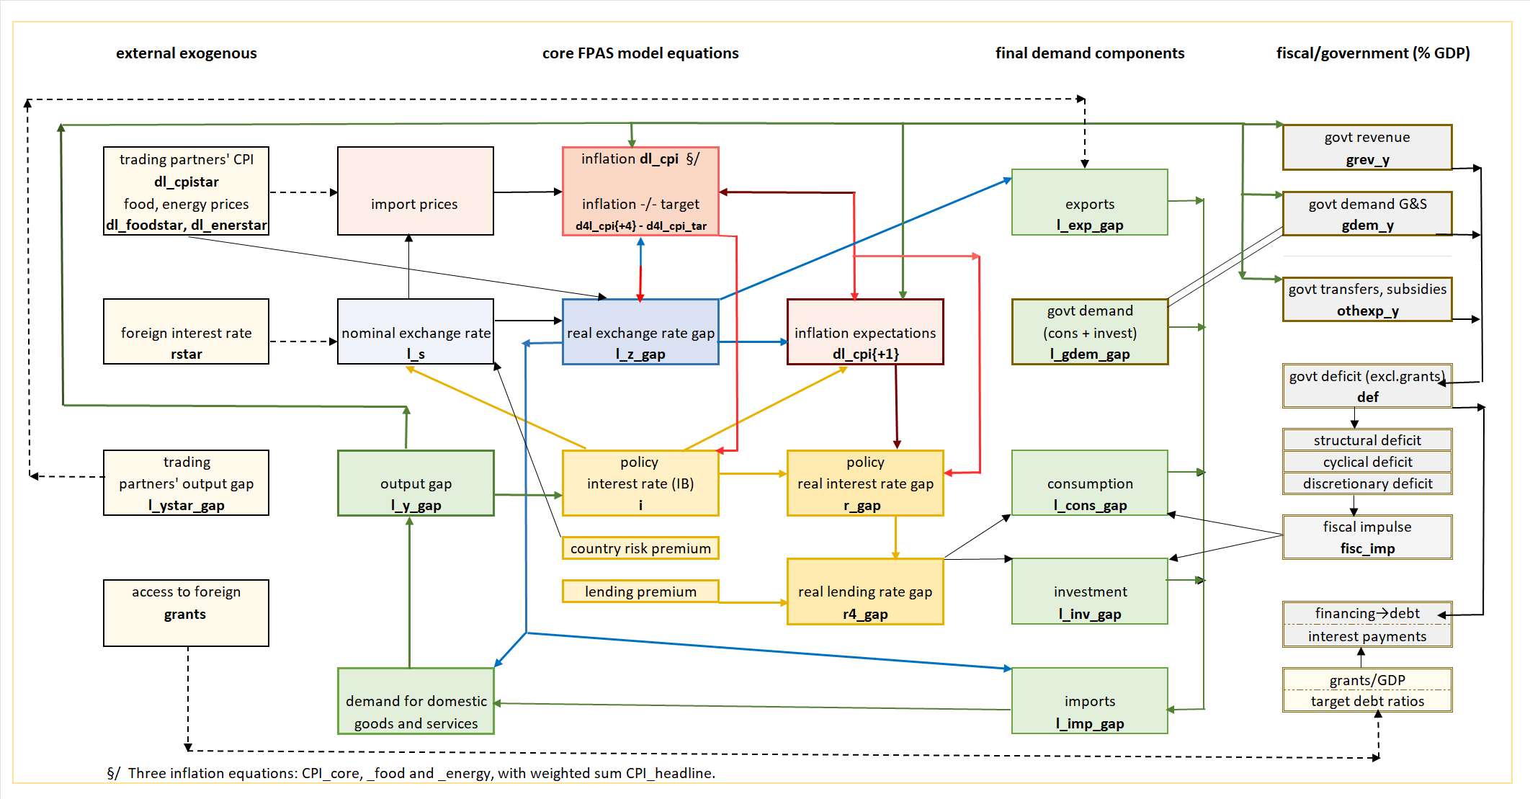

Figure A1.2 Standard FPAS Quarterly Projection Model
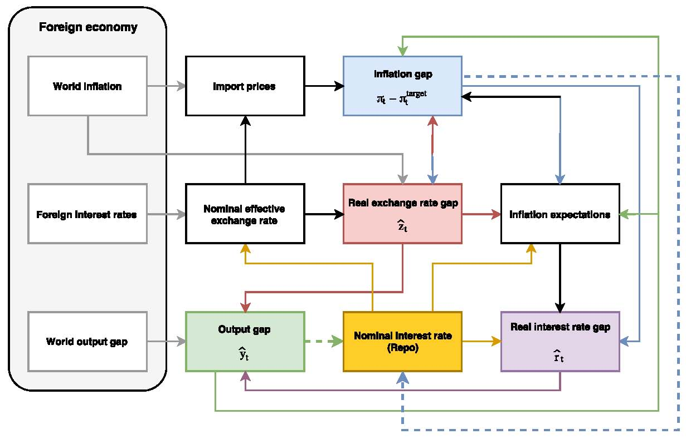
Source: Botha et. al.(2017) The Quarterly Projection Model of the SARB, South African Reserve Bank Working Paper Series, WP/17/01.

Annex 2. Model calibration/filtering using model properties and historical data (2006-23Q2)
This Annex summarizes how the model is calibrated, i.e., parameters are set and subsequently adjusted to ensure (i) plausible responses to shocks (IRF); (ii) a good fit to historic data and reasonable trends and gaps; (iii) accurate historical forecasts; and (iv) plausible future forecasts.
The model’s equation coefficients are set using FPAS studies for Rwanda (NBR, IMF) and other countries in the region, Africa and elsewhere, and information or judgement. Standard deviations (SD) of shocks are initially set as parameters using other studies. Steady states are set as parameters based on discussion with officials. In the calibration process, four avenues are followed to adjust parameters to improve model accuracy.
Model features. Impulse response functions (IRF) are derived from the model’s reduced form, with each endogenous variable expressed as a function of the coefficients and shocks in all relevant equations. A shock in equation j induces responses in all variables i, and the IRF of variable i to shock j is a function of model parameters alone. E.g., the direct effect of a 1% investment shock should lead to an initial effect on GDP corresponding to the share of investment in GDP times the domestic share of investment. The initial output increase raises consumption and investment, which both raise output in turn, and this is the indirect effect. Further effects are generated as the higher output gap increases inflation, both triggering an interest rate response, with an effect on RIR and consumption and investment, etc. Analysis of the IRF usually leads to adjustment of model coefficients, and this in an iterative way.
Filtering. Unobserved variables (trends and gaps of demands, exchange rate and relative prices) derive from model-wide use of the Kalman filter, which optimizes a criterion function for the set of calibrated SD of shocks over 2006Q1─2022Q2 or latest quarter with available data. After estimating the unobserved and calculating the historic, data SD of variables, gaps, and shocks, each data-based SD is compared with the corresponding calibrated, model SD of the same variable (the latter calculated as function of calibrated SD of shocks and coefficients). In case of large differences, the calibrated, model SD of shocks are adjusted to bring the calibrated, model SD closer to the data-based SD of each variable. Also, judgement about smoothness of trends (e.g., output) leads us to adjust SD. The lower the SD for the shock in a gap equation, the less smooth the trend; and the lower the SD for the shock in a trend equation, the smoother the trend, i.e., the closer to the steady state. E.g., the SD of the growth rates of CPI-core, -food, and -energy were increased to match the data-based SD of these variables as calculated from the filtering outcome.
Historical forecasts. For each quarter t in the historic period, the model uses observation of endogenous variables up to that quarter (taking as given all external variables at their observed levels) to make forecasts for the 8 periods ahead, through t+8. If the historical forecasts for a variable are far from the observed levels (i.e., the RMSE is high)—and not explained by the deviation of actual policies from policy rules—parameters (coefficients and/or SD of shocks) are adjusted. E.g., to improve the poor initial results for CPI-ener and make the forecast less volatile, the coefficients for the direct and indirect import price effects were lowered, that of persistence increased, and that of the expected price lowered.
Forecasts into future. Based on initial forecast results, the assessment of plausibility can lead to adjustment of model parameters. E.g., if the forecast shows a response of the policy rate to the expected inflation{+4Q} deviation from target inflation which is judged too timid, then the coefficient in the policy rule equation may need to be increased. Similarly, to avoid too high volatility in forecast CPI-food and CPI-energy, the coefficients of the direct effect (of foreign prices times exchange rate) were reduced.
Forecast errors. Using the assumed normal distributions of shocks (based on observed past shocks and calibrated distributions of shocks), the errors for each forecast variable-period are calculated.

Annex 3. Recent developments of other final demands and decomposition (2015-23Q2)
Private investment (fixed capital formation and change in inventories) is subject to high fluctuations due to the nature of investment decisions and residual character of inventories in national account estimates. Private investment suffered much early in the pandemic, and a modest recovery in early 2021 was interrupted by another adverse shock in Q4. The decline in investment contributed much to the fall in GDP under Covid. Since then, the negative investment gap (relative to trend) has been resorbed, helped by negative RIR lending rates in recent periods (Figure A3.1). The impact of the fiscal impulse on private investment is considered to be small.
Figure A3.1 Investment growth y-on-y and trend in %, and invetsment gap and its drivers, 2015-23
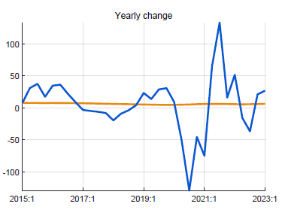 | 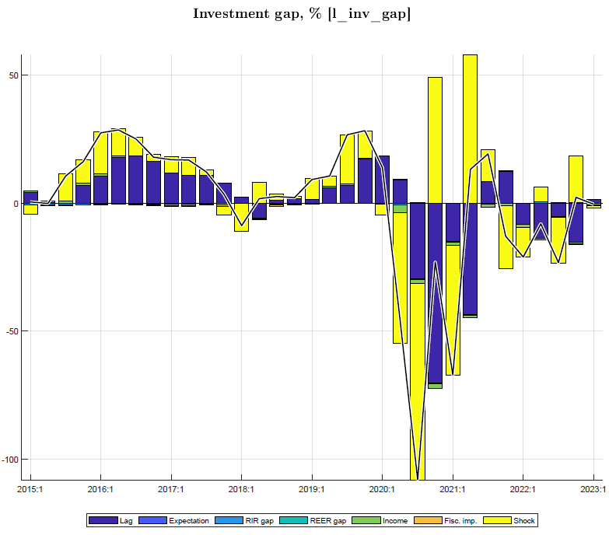
Exports of G&S growth is relatively stable within the year. At the start of Covid in 2020Q2, exports of goods (mineral) and services (tourism) fell sharply and stayed depressed until early 2022, contributing strongly to the drop in GDP. The recovery from the negative export gap took until mid-2022. During Covid, it was helped by an increasing RER, but thereafter hampered by a decreasing RER, albeit with a small coefficient (Figure A3.2).
Figure A3.2 Export growth y-on-y and trend in %, and export gap and its drivers, 2015-23
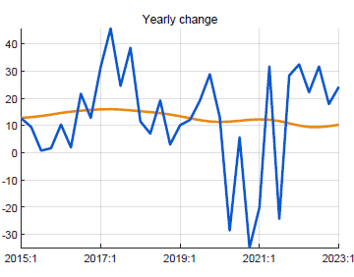 | 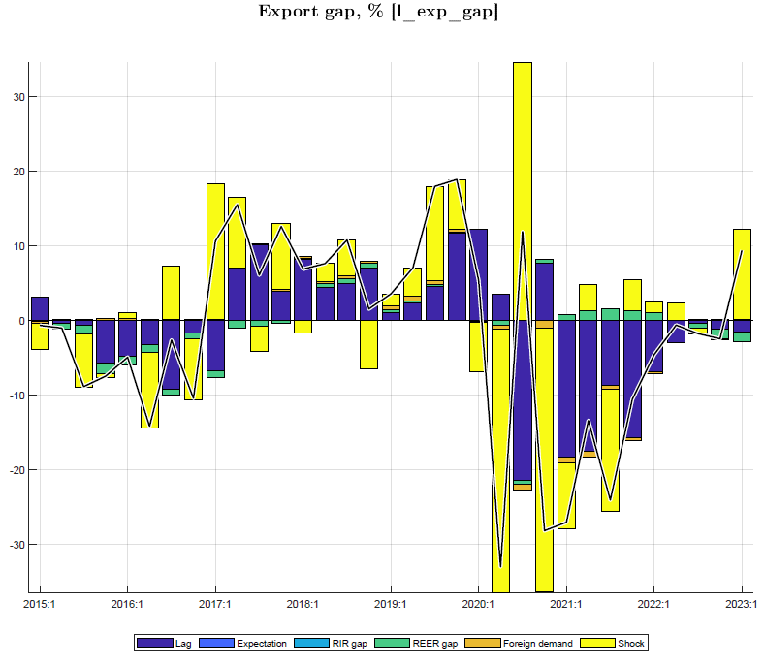
Imports of G&S are the weighted sum of import shares in final demand components (C, I, G, E) with, in addition, a negative effect of the RER (Figure A3.3). The drop in imports during Covid due to both supply constraints and lack of demand, constituted a favorable shift toward domestic demand and offset somewhat the down pull effect from private consumption, exports and investment. Thus, in periods when imports fell relative to trend, there was a positive effect on output (Figure 1.2). The discrepancy shocks reflect the difference between the actual import and GDP shares of each final demand component and the calibrated shares.
Figure A3.3 Import growth y-on-y and trend in %, and import gap and its driver, 2015-23
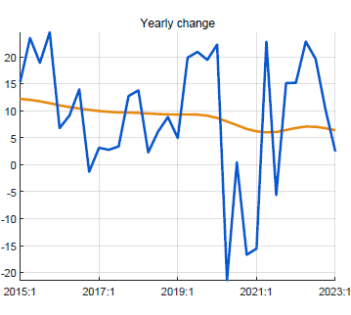 | 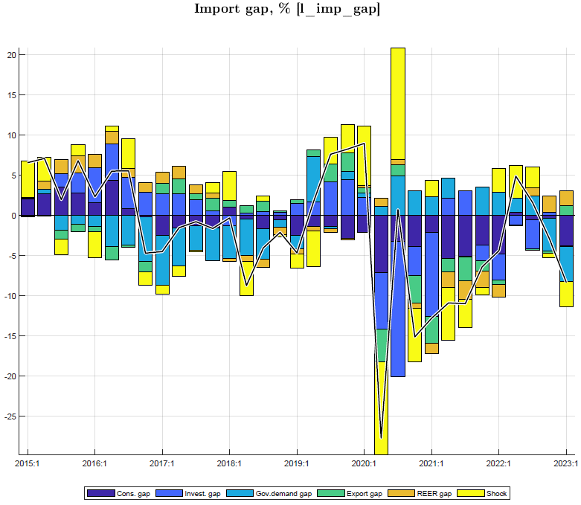

Annex 4. Fiscal block: deficit, fiscal policies, and fiscal impulse in the model
This Annex highlights the key features and concepts used in the elaborate fiscal block, which allows simulating a variety of fiscal policies and analyzing interaction with monetary policies.
The fiscal targets/anchor guiding government decisions on deficit (excl. grants, % of GDP) is the “structural deficit trend” which converges to the steady state deficit, consistent with the target debt-to-GDP ratio, taking into account: access to grants, trend real growth rate, trading partner and domestic inflation rates, trend RER depreciation rate, and envisaged share of domestic debt in total debt.
Deficit excluding grants is defined as: government demand for goods and services for consumption and investment (“gdem”) plus other spending (transfers, subsidies, part of Economic Recovery Fund spending, interest payments, ...) minus revenue, in % of GDP. The model has equations for the deficit and its components and for gdem (see below).
The deficit is decomposed into structural deficit (long-term trend), cyclical deficit (business cycle-induced change in deficit) and discretionary deficit (the remainder, discretionary fiscal policies).
The structural deficit is the trend deficit converging to the steady state defined by the target debt/GDP ratio and is the key outcome of the fiscal rule.
The cyclical deficit—also called (semi-)automatic stabilizer—is positive in a downturn, as government collects less revenue relative to GDP (postponed tax payments, waivers, lower profits,.) and spends more on transfers and subsidies via the social security system, and negative (surplus) in a boom, as revenue/GDP increases and spending/GDP falls. The social security stabilizer is still small in Rwanda but bound to gain importance over time as social spending gets institutionalized.
The discretionary deficit contains remaining ad hoc components of fiscal policies, mainly spending for specific needs, i.e., gdem in deviation from its trend, and some ad-hoc impact on revenue collection (e.g., bandwidth auction, ad hoc tax exemptions, ...).
Estimation of deficits and government demand for G&S. Structural and discretionary deficit equations are estimated from filtering historical data, each as function of its lag (AR(1), its steady state (zero for discretionary deficit), gdem, and shocks. The cyclical deficit is a function of output gap.
Similarly, gdem is decomposed into trend and gap, estimated from filtering historical data and also with AR(1). The Kalman filter finds the best decomposition of deficit components and gdem trend and gap (and simultaneously also for all other unobserved variables, incl. output gap), for given or calibrated Standard Deviations of the shocks in the equations.
The fiscal impulse is defined as government discretionary deficit plus change in structural deficit in % of GDP. It is a common measure of the expansionary (contractionary) nature of fiscal policies, capturing both the direct demand impulse toward output (from gdem) and the indirect one (via private sector income affected by transfers/subsidies and taxes, and hence consumption and investment). In this model, the two are separated as follows.
Fiscal policies and fiscal impulse (Figure A4.1)
Fiscal policies in the model affect demand and output in three ways, unlike most FPAS models:^{1/}
--gdem via its own model equation has a direct effect on output, which equals gdem times the domestic demand share (one minus import share)
--the fiscal impulse influences private demand and has an indirect effect on output
--the two effects generate other indirect effects on output as output (income) is among the drivers of private demand, thus generating further demand effects etc. (multiplier).
Figure A4.1 Output gap and fiscal policies, 2017-26 (in % of GDP)
Fig. A4.1
--gdem gap is % deviation from its trend, here weighted with the share of govt demand in GDP
--direct effect of gdem is the gap times the share of govt demand dem in GDP times the domestic share of gdem
--fiscal impulse (defined as discretionary deficit plus change in structural deficit) affects private demand
--in Covid years 2020-22, the fiscal impulse has been on average over 2% of GDP, mainly on account of spending on G&S and transfers
--output gap has drivers other than govt demand (i.e., consumption, investment, ex/imports), in turn influenced by the RIR and RER
--fiscal expansion under Covid: the direct and indirect effect is estimated to have mitigated the negative output gap by some 1.5% of GDP

1/ In FPAS models that include fiscal policy, a fiscal stance variable typically appears in the output gap equation, along with lag, lead, and RIR, RER, etc.

Prepared by QMFM team consisting of Didier Tabaro, Evariste Karenzo, Swadiq Ishimwe, Elie Sebagabo, and Arend Kouwenaar.
Annex 1 summarizes the main features and transmission mechanisms of the quarterly model used.
Annex 2 summarizes model calibration/filtering to as to: fit the data, explain macro variables by their main drivers, derive plausible impulse responses of macro variables to shocks, and obtain credible historical forecasts.
Other spending (not on G&S) consists of transfers and subsidies, net lending, and domestic interest.
GFCF, Gross Fixed Capital Formation in National Accounts; Net Investment in Nonfinancial Assets in GFS2014 (intMF: NANFA).
This study defines “fiscal impulse” as the discretionary deficit plus the change in the structural deficit (excl. grants, in % of GDP).
In contrast, many studies use fiscal impulse—defined in various ways—to denote the total effect of the fiscal policy stance on demand and output, i.e., both the direct effect of government demand for G&S and the indirect effect of induced private demand.
NBR has standing lending and deposit facilities, with rates 1% above and below the CBR. Since June 2020, the actual reverse repo (lending to banks) and repo (deposits by banks) rates have been identical to the CBR. Before that, the actual average rates were mostly in-between the CBR (or its predecessor Key Repo Rate) and the standing and deposit rates, respectively.
The NBR follows an unwritten, modeled interest rate ‘policy rule’ aimed at meeting the inflation target and minimizing output fluctuations, while utilizing discretion to deviate from the rule.
The neutral rate is driven by foreign real interest rate (3-month US government bonds, currently -1 to 0%, but rising), target core inflation (4.5%), country risk premium (estimated at 2%), and trend real exchange rate depreciation.(currently estimated at 0%).
Based on world real interest rates, target domestic core inflation, country risk premium, and expected rate of RER depreciation, currently at -1%, 4.5%, 2% and 2%, i.e. neutral policy rate of 7.5%. It will be higher when international interest rates turn positive again.
For NPV of debt/GDP ratio of 45% and for retained assumptions on growth, inflation, debt composition, etc. See footnote 14 below.
The 2023/24 and 2024/25 Budget deficits and spending on G&S have been tuned based on the semester breakdown of annual figures (because the projected quarterly breakdown is not available), hence quarters are the same within the semester.
The QMFM sustainable debt-creating deficit is 5% of GDP under assumptions of: debt/GDP target of 55% (45% in NPV terms, o/w 10% domestic and 35% foreign, for grant element 22%), real GDP growth 7.5% p.y., trading partner inflation 2%, and trend RER depreciation rate 0%. The structural deficit (before structural grants of 3% of GDP) consists of revenue 21%, government consumption 13%, investment 11%, and other spending 5% of GDP.
In contrast, the IMF-program projection beyond PCI years foresees a sustainable debt-creating deficit of below 2.5% of GDP, which would be consistent with a debt/GDP target below 30% (25% in NPV terms). This is in contradiction with the original PCI (Dec 2022) target of debt/GDP of 65% (50% in NPV terms) that implies a sustainable debt-creating deficit of 5.5% of GDP.
The scope for quickly and effectively expanding social transfers and programs has been limited, even in Covid times, but this changes as social protection mechanisms improve.
Compared to country risk premiums for South Africa (SARB): 3%, Ghana (BoG): 5%.
Unless there was pre-Covid real overvaluation as IMF staff has argued (some 20%). If we built this in in the initial condition, a stronger nominal RER depreciation will ensue for 2024-27.
The Forecasting and Policy Analysis Systems (FPAS) for use by Central Banks were developed by the IMF from the early 2000s. ‘System’ refers to the combination of a quarterly projection model (QPM), a time-series based now/forecasting tool, other satellite models (e.g., fiscal, labor market,..), and policy preparation and communication processes.
Many Ministries of Finance use DSGE, incorporating monetary and fiscal policies, for 3-5 year forecasts, especially in EU and Nordic countries (see recent surveys). They have clear advantages compared to macro-econometric models.

